Router 1 hostname
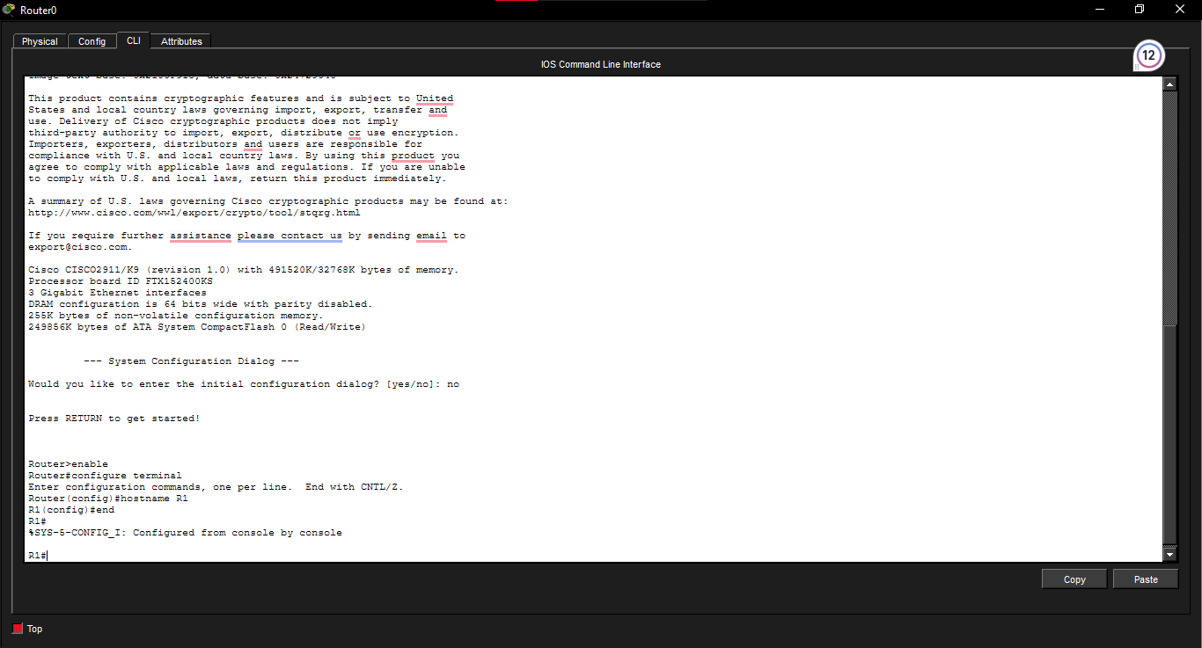

Router 2 hostname
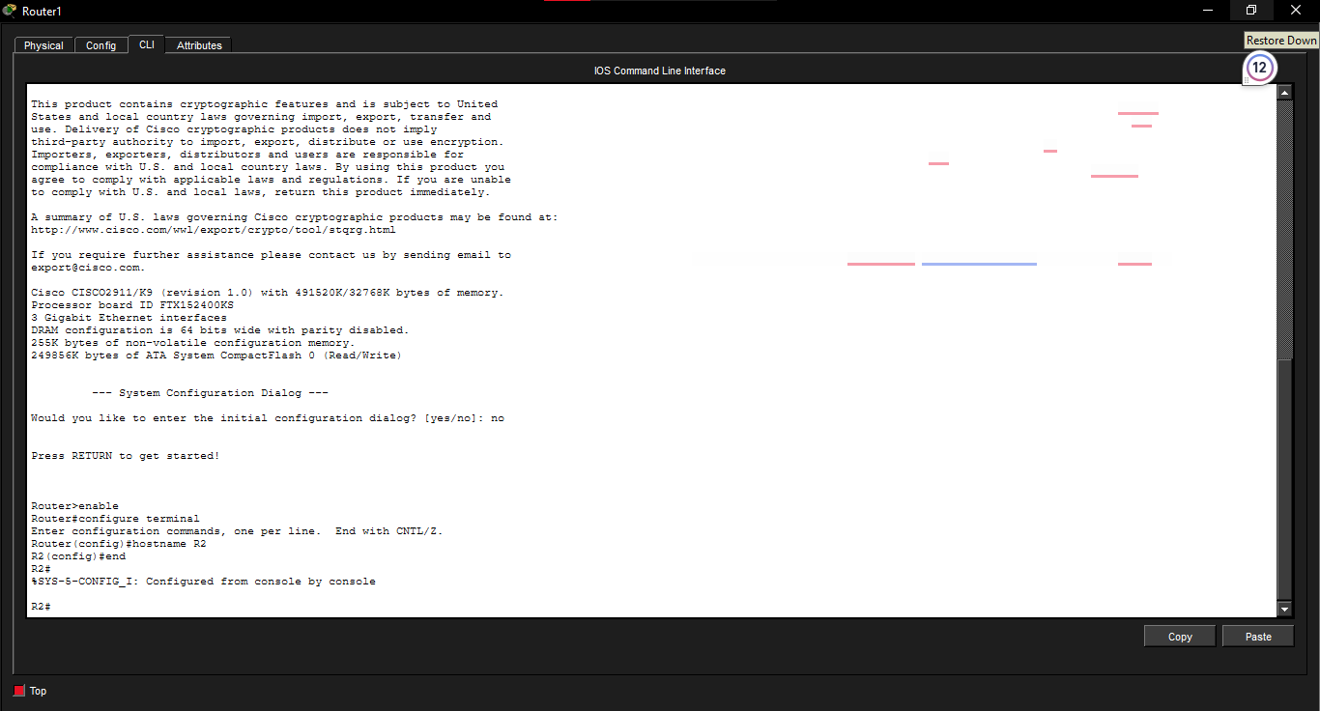

Switch 1 hostname
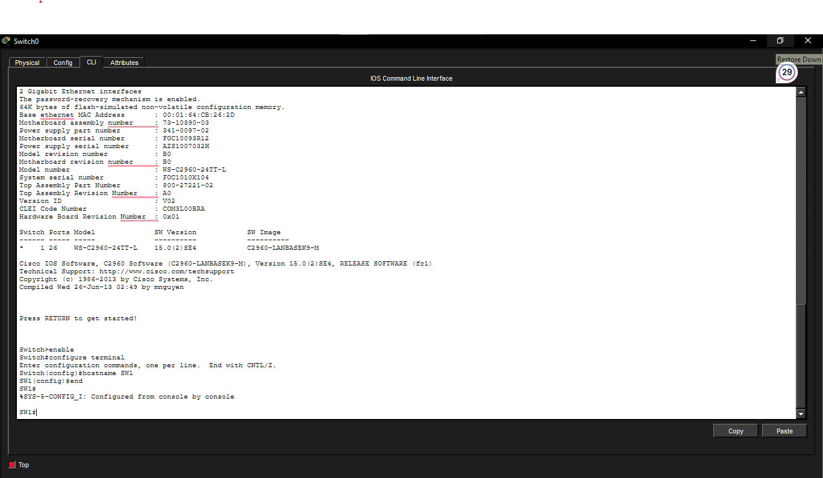
R1 IP configuration

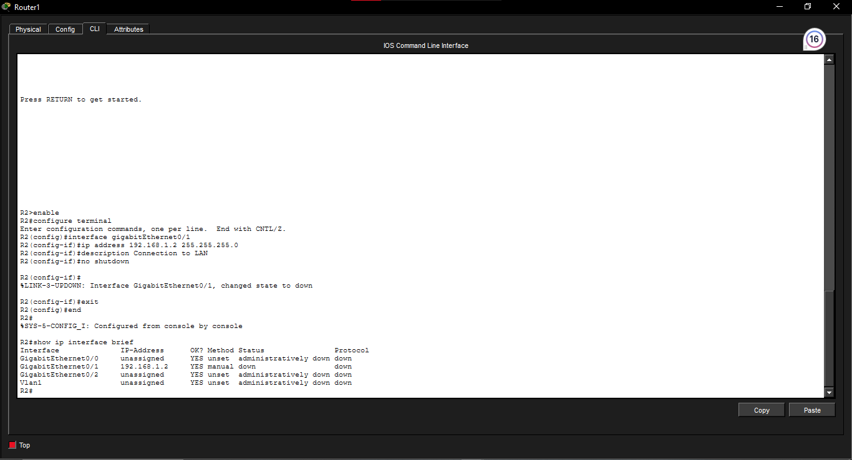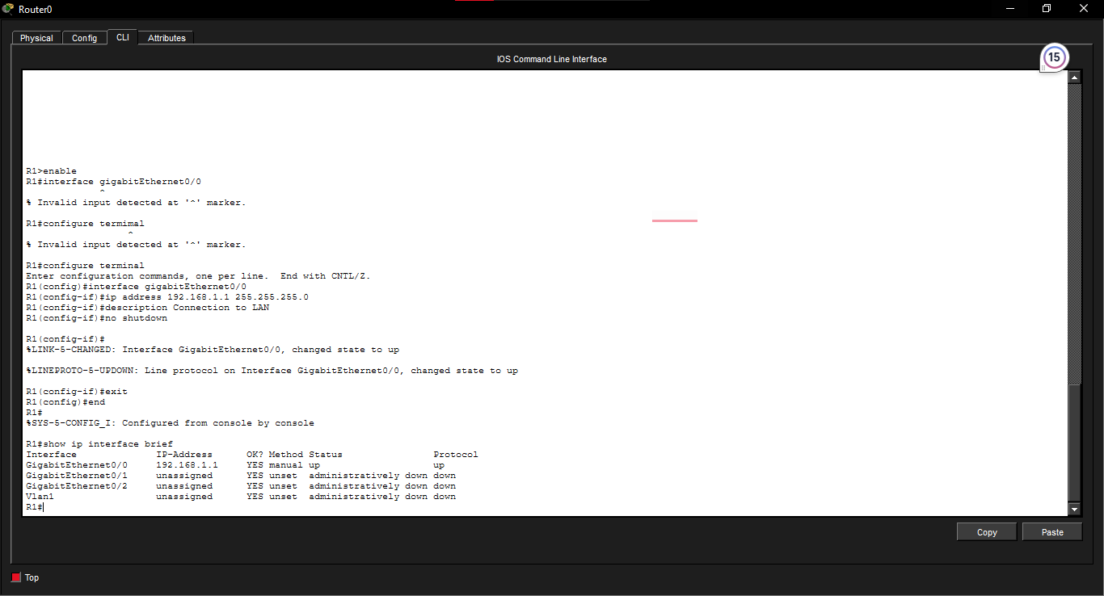

Reflection question
A duplex mismatch can cause slow network performance, errors and collisions on half-duplex links. Both ends should use compatible duplex settings.

